Patient Insurance Declaration

Our Reference:

Dear Patient,

Most major insurance companies will pay for a course of osteopathic treatment. The level of cover depends on the individual policy. Most policies have a deductible or excess for which the patient is liable. Any shortfall that is not paid by the insurance company remains the full liability of the patients themselves.

Please note that most referrals will need a GP signature that pre-dates the first consultation.

We ask all patients to sign this declaration to agree payment of any shortfall should it arise. The cost of consultation and treatments are ultimately the responsibility of the patient with whom the practitioner has an agreement. When full or interim invoices are submitted to the respective insurance company payment is assessed and then usually made within one month of invoice submission. Any shortfall will need to paid within fourteen days of any relevant notifications.

I have read and agree to the above terms:

Name: ……………………………………………………………………………………………………

Signed: ……………………………………………………………………………………………………

Dated: …………………………………………………………………………………………………….

Yours faithfully,
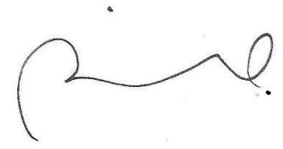

Rohan Iswariah D.O.

