Dear Patient,

We politely request that you give us at least 24 hours notice if you need to cancel or rearrange an appointment.

A minimum fee of £20 needs to be charged if insufficient notice is given, unless the appointment can be filled.

I have read and agree to the above terms:

Name: ……………………………………………………………………………………………………

Signed: ……………………………………………………………………………………………………

Dated: …………………………………………………………………………………………………….

Yours faithfully,
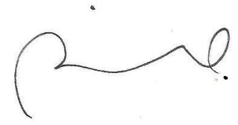

Rohan Iswariah D.O.

